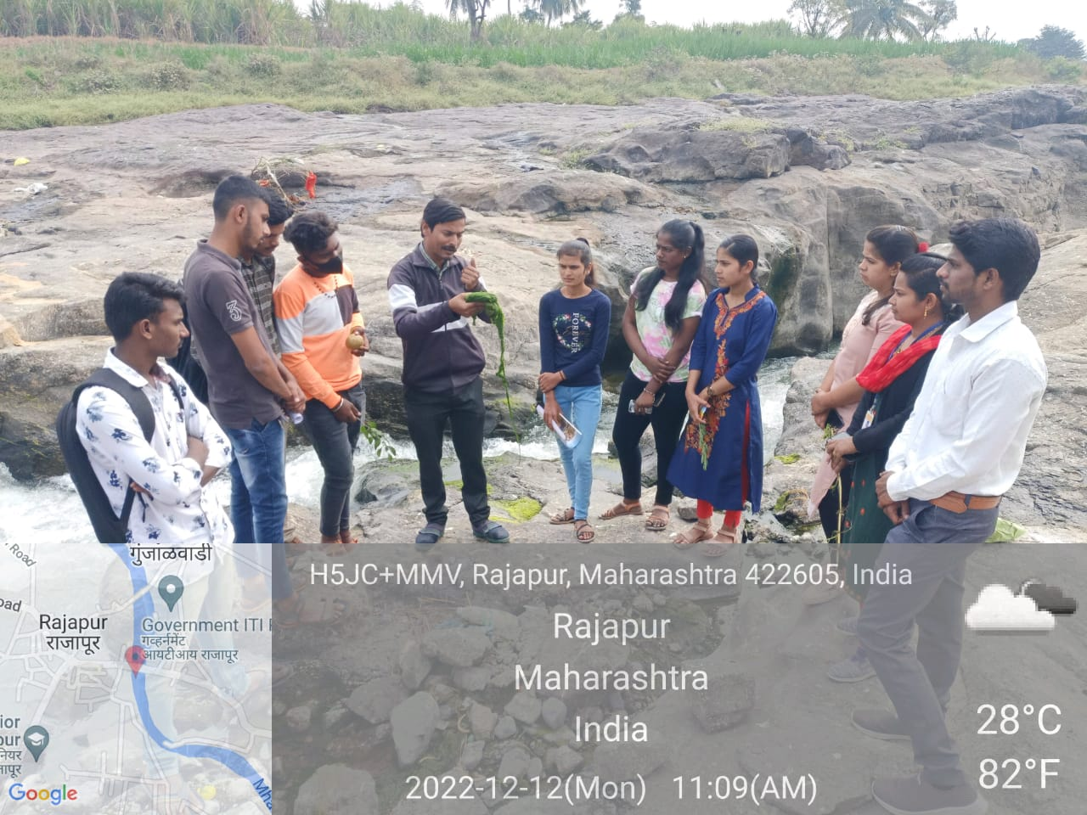

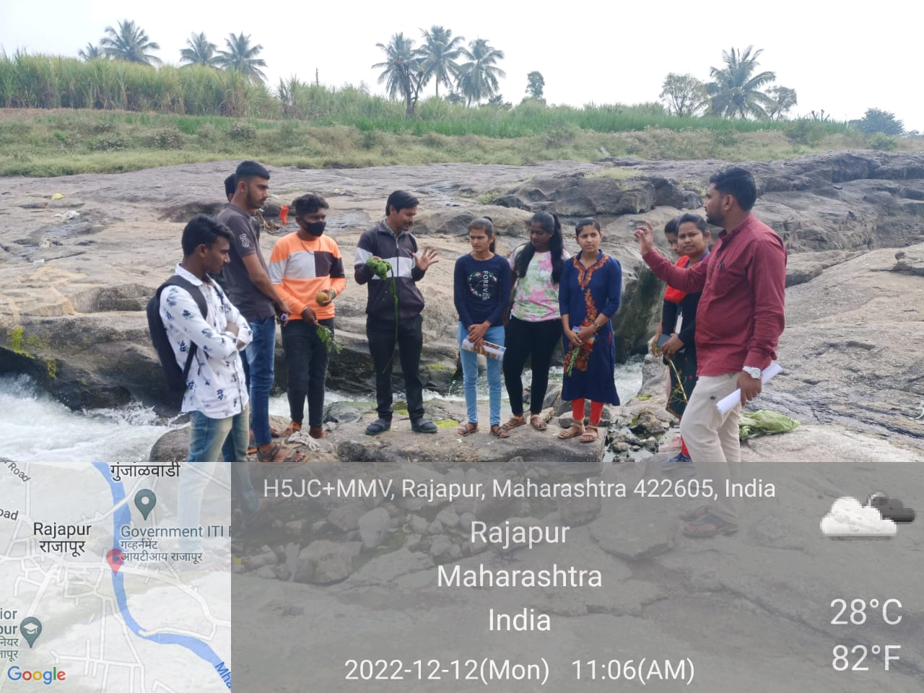

- Field visit in Rajapur river On field demostration Head of Department in Zoology prof. Shaharukh Khan for the students with vice principal prof.Subhash Varpe.
- Explain the eutrophication of river,lake & pond.
- Examine the aquatic microscopic Fauna for the callected sample.
- Disolve these sample carbondioxide,oxygen, ph & water holding capacity
- Eutorphication most commonly arises from the oversupply of nutrients, most commonly as nitrogen or phosphorus, which leads to overgrowth of plants and algae in aquatic ecosystems. After such organisms die, bacterial degradation of their biomass results in oxygen consumption, there by creating the state of hypoxia. The larger aquatic animals like fishes are killed due to suffocation.
- Dissolved oxygen (D.O.) is a measure of the ability of a water body to support a well- balanced aquatic life. Insufficient dissolved oxygen in water leads to the onset of anaerobic conditions and subsequently to the release of odourous or noxious gases such as H₂S. So the measurement of the D.O. in a water body is of particular importance when dissolved oxygen is sufficiently present in a water body organic materials, and wastes are degraded effectively.

